# EXPERIMENT 1

**AIM:** Write a program for performing batch gradient descent and stochastic gradient descent.

**THEORY:**

## BATCH GRADIENT DESCENT:

**CODE:**

import numpy as np # type: ignore # Example data

# Features: x1, x2 and Target: y data = np.array([

[1, 2, 3], # x1, x2, y

[2, 4, 5],

[3, 6, 7],

[4, 8, 9]

])

# Split features (x) and target (y) X = data[:, :-1] # Features (x1, x2)

y = data[:, -1] # Target (y)

# Add a bias term (column of ones for Q0) to the features

X = np.c_[np.ones(X.shape[0]), X] # Adding bias (or Q0) as the first column

# Hyperparameters learning_rate = 0.02

epochs = 10000 # Number of iterations threshold = 0.000002

# Initialize weights (Q0, Q1, Q2) to zeros weights = np.zeros(X.shape[1])

# Batch Gradient Descent

m = len(y) # Number of data points for epoch in range(epochs):

# Compute predictions y_hat = np.dot(X, weights)

# Compute error error = y_hat - y

# Compute gradients

gradients = (1 / m) * np.dot(X.T, error)

# Update weights

weights = weights - learning_rate * gradients cost = (1 / (2 * m)) * np.sum(error ** 2)

# (Optional) Print progress

if epoch % 100 == 0 or epoch == epochs - 1:

print(f"Epoch {epoch + 1}/{epochs}, Cost: {cost:.4f}, Weights: {weights}" if cost<=threshold:

print(f"Epoch {epoch + 1}/{epochs}, Cost: {cost:.4f}, Weights: {weights}") break

# Final weights

print("\nFinal Weights:")

print(f"Q0 (Intercept): {weights[0]:.4f}")

print(f"Q1 (Coefficient for x1): {weights[1]:.4f}") print(f"Q2 (Coefficient for x2): {weights[2]:.4f}")

**CODE OUTPUT:**

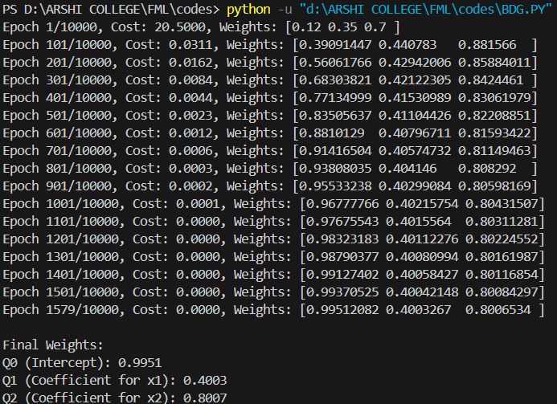

## STOCHASTIC GRADIENT DESCENT:

**CODE:**

import numpy as np

# Example data

# Features: x1, x2 and Target: y data = np.array([

[1, 2, 3], # x1, x2, y

[2, 4, 5],

[3, 6, 7],

[4, 8, 9]

])

# Split features (x) and target (y) X = data[:, :-1] # Features (x1, x2)

y = data[:, -1] # Target (y)

# Add a bias term (column of ones for b0) to the features

X = np.c_[np.ones(X.shape[0]), X] # Adding bias (or Q0) as the first column

# Hyperparameters learning_rate = 0.01

epochs = 100 # Number of passes through the dataset threshold = 0.02

# Initialize weights (Q0, Q1, Q2) to zeros weights = np.zeros(X.shape[1])

# Stochastic Gradient Descent for epoch in range(epochs):

for i in range(len(X)):

# Predict y_hat

y_hat = np.dot(X[i], weights) # print(X[i])

# Compute error error = y_hat - y[i]

# Update weights

weights = weights - learning_rate * error * X[i]

cost = (1 / (2 * len(X))) * np.sum((np.dot(X, weights) - y) ** 2) # (Optional) Print progress

if epoch % 10 == 0 or epoch == epochs - 1:

# cost = (1 / (2 * len(X))) * np.sum((np.dot(X, weights) - y) ** 2)

print(f"Epoch {epoch + 1}/{epochs}, Cost: {cost:.4f}, Weights: {weights}")

if cost<=threshold:

print(f"Epoch {epoch + 1}/{epochs}, Cost: {cost:.4f}, Weights: {weights}") break

# Final weights

print("\nFinal Weights:")

print(f"Q0 (Intercept): {weights[0]:.4f}")

print(f"Q1 (Coefficient for x1): {weights[1]:.4f}") print(f"Q2 (Coefficient for x2): {weights[2]:.4f}")

**CODE OUTPUT:**

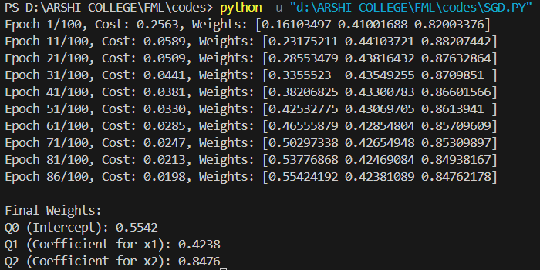

**LEARNING OUTCOME:**

# EXPERIMENT 2

**AIM:** Write a program for performing simple linear regression using and without using libraries.

**THEORY:**

## SIMPLE LINEAR REGRESSION (WITHOUT LIBRARIES):

**CODE:**

import numpy as np

import matplotlib.pyplot as plt import pandas as pd

def load_dataset():

dataset = pd.read_csv("Salary_Data[1].csv") X = dataset.iloc[:, :-1].values

Y = dataset.iloc[:, -1].values.reshape(-1, 1)

# Handling missing data

mean_X = np.nanmean(X) # Compute mean of non-null values X[np.isnan(X)] = mean_X # Replace NaN values with mean

# Standardizing the data (optional but recommended) X = (X - np.mean(X)) / np.std(X)

Y = (Y - np.mean(Y)) / np.std(Y)

# Splitting data into training (67%) and test (33%) sets test_size = int(len(X) * 0.33)

indices = np.random.permutation(len(X))

X_train, Y_train = X[indices[:-test_size]], Y[indices[:-test_size]] X_test, Y_test = X[indices[-test_size:]], Y[indices[-test_size:]]

return X_train, Y_train, X_test, Y_test

def compute_coefficients(x, y):

# Computing slope (m) and intercept (b) using Least Squares Method num = np.sum((x - np.mean(x)) * (y - np.mean(y)))

den = np.sum((x - np.mean(x))**2) m = num / den

b = np.mean(y) - m * np.mean(x) return b, m

def plot_regression_line(x, y, coeff):

plt.scatter(x, y, color='red', marker='o', label="Data points") y_pred = coeff[0] + coeff[1] * x # Regression line

plt.plot(x, y_pred, color='green', label="Regression line") plt.title("Simple Linear Regression")

plt.xlabel("Experience") plt.ylabel("Salary")

plt.legend() plt.show()

# Calculate Mean Squared Error mse = np.mean((y - y_pred) ** 2)

print(f'Mean Squared Error = {mse:.4f}')

def main():

X_train, Y_train, X_test, Y_test = load_dataset() coeff = compute_coefficients(X_train, Y_train)

print(f"Regression Line: Y = {coeff[0]:.4f} + {coeff[1]:.4f}X") plot_regression_line(X_train, Y_train, coeff) # Train set plot_regression_line(X_test, Y_test, coeff) # Test set

if name == " main ": main()

**CODE OUTPUT:**

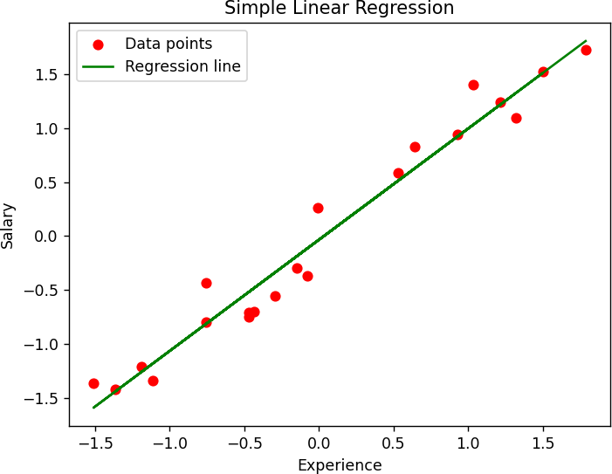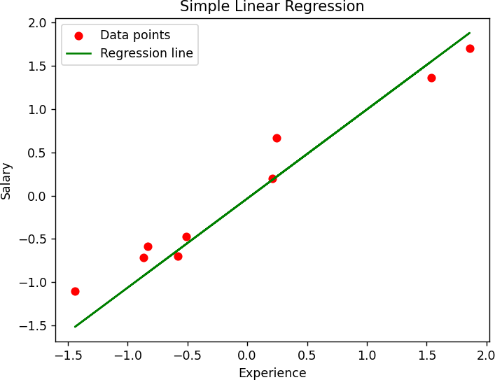

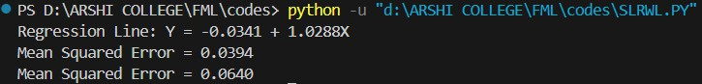

## SIMPLE LINEAR REGRESSION (WITH LIBRARIES):

**CODE:**

# Importing Libraries import numpy as np

import matplotlib.pyplot as plt

def mean_squared_error(y_true, y_predicted):

# Calculating the loss or cost

cost = np.sum((y_true-y_predicted)**2) / len(y_true) return cost

# Gradient Descent Function

# Here iterations, learning_rate, stopping_threshold # are hyperparameters that can be tuned

def gradient_descent(x, y, iterations = 1000, learning_rate = 0.0001, stopping_threshold = 1e-6):

# Initializing weight, bias, learning rate and iterations current_weight = 0.1

current_bias = 0.01 iterations = iterations learning_rate = learning_rate n = float(len(x))

costs = [] weights = []

previous_cost = None

# Estimation of optimal parameters

for i in range(iterations):

# Making predictions

y_predicted = (current_weight * x) + current_bias

# Calculating the current cost

current_cost = mean_squared_error(y, y_predicted)

# If the change in cost is less than or equal to

# stopping_threshold we stop the gradient descent

if previous_cost and abs(previous_cost-current_cost)<=stopping_threshold: break

previous_cost = current_cost

costs.append(current_cost) weights.append(current_weight)

# Calculating the gradients

weight_derivative = -(2/n) * sum(x * (y-y_predicted)) bias_derivative = -(2/n) * sum(y-y_predicted)

# Updating weights and bias

current_weight = current_weight - (learning_rate * weight_derivative) current_bias = current_bias - (learning_rate * bias_derivative)

# Printing the parameters for each 1000th iteration print(f"Iteration {i+1}: Cost {current_cost}, Weight \

{current_weight}, Bias {current_bias}")

# Visualizing the weights and cost at for all iterations plt.figure(figsize = (8,6))

plt.plot(weights, costs)

plt.scatter(weights, costs, marker='o', color='red')

plt.title("Cost vs Weights") plt.ylabel("Cost") plt.xlabel("Weight") plt.show()

return current_weight, current_bias

def main():

# Data

X = np.array([32.50234527, 53.42680403, 61.53035803, 47.47563963, 59.81320787,

55.14218841, 52.21179669, 39.29956669, 48.10504169, 52.55001444,

45.41973014, 54.35163488, 44.1640495 , 58.16847072, 56.72720806,

48.95588857, 44.68719623, 60.29732685, 45.61864377, 38.81681754])

Y = np.array([31.70700585, 68.77759598, 62.5623823 , 71.54663223, 87.23092513,

78.21151827, 79.64197305, 59.17148932, 75.3312423 , 71.30087989,

55.16567715, 82.47884676, 62.00892325, 75.39287043, 81.43619216,

60.72360244, 82.89250373, 97.37989686, 48.84715332, 56.87721319])

# Estimating weight and bias using gradient descent

estimated_weight, estimated_bias = gradient_descent(X, Y, iterations=2000)

print(f"Estimated Weight: {estimated_weight}\nEstimated Bias: {estimated_bias}")

# Making predictions using estimated parameters Y_pred = estimated_weight*X + estimated_bias

# Plotting the regression line plt.figure(figsize = (8,6))

plt.scatter(X, Y, marker='o', color='red')

plt.plot([min(X), max(X)], [min(Y_pred), max(Y_pred)], color='blue',markerfacecolor='red', markersize=10,linestyle='dashed')

plt.xlabel("X")

plt.ylabel("Y") plt.show()

if name ==" main ": main()

**CODE OUTPUT:**

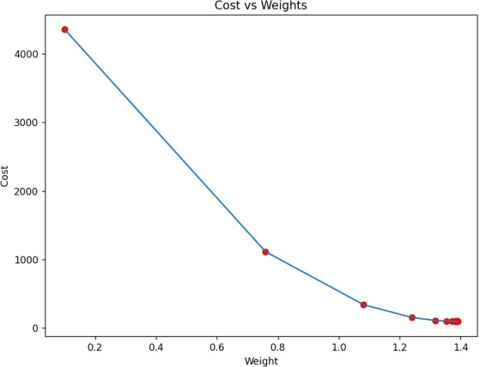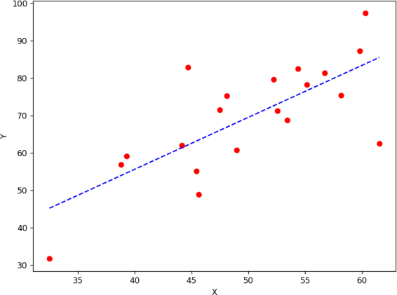

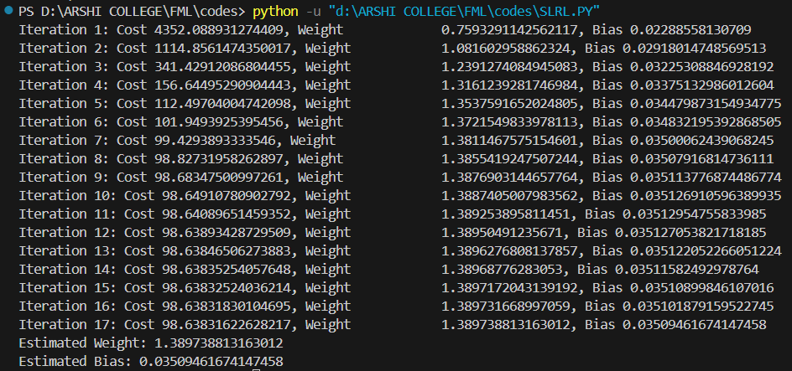

**LEARNING OUTCOME:**

# EXPERIMENT 3

**AIM:** Write a program for performing multiple linear regression using and without using libraries.

**THEORY:**

## MULTIPLE LINEAR REGRESSION (WITH LIBRARIES):

**CODE:**

import numpy as np

import matplotlib.pyplot as plt import pandas as pd

import seaborn as sns

df = pd.read_csv('AMZN.csv') df.shape

df.head()

df.drop('Date',axis=1,inplace=True) df.drop('Company',axis=1,inplace=True) df.head()

df.corr()

sns.heatmap(df.corr(),annot=True,cmap='YlOrRd',linewidth=0.5,linecolor='yellow') from sklearn.model_selection import train_test_split

X = df.drop('Adj Close',axis=1) Y = df['Adj Close']

X_train, X_test, y_train, y_test = train_test_split(X, Y, test_size = 0.2, random_state = 0) from sklearn import linear_model, metrics

regressor = linear_model.LinearRegression() regressor.fit(X_train, y_train)

y_pred = regressor.predict(X_test) print("Coefficients: ",regressor.coef_)

print("Variance score: {}".format(regressor.score(X_test,y_test))) np.set_printoptions(precision=2)

print(np.concatenate((y_pred.reshape(len(y_pred),1), y_test.reshape(len(y_test),1)),1)) plt.hist((y_pred-y_test)*100/y_test)

from sklearn import metrics

metrics.mean_squared_error(y_test,y_pred)

**CODE OUTPUT:**

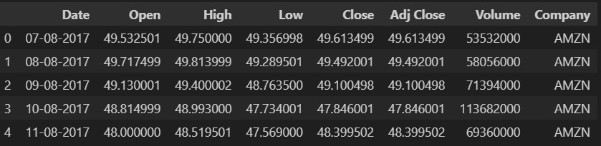

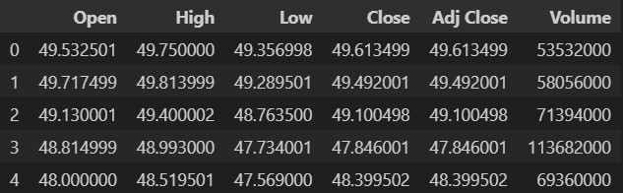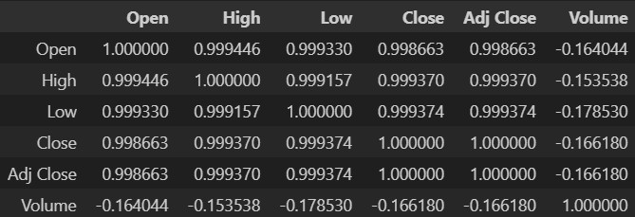

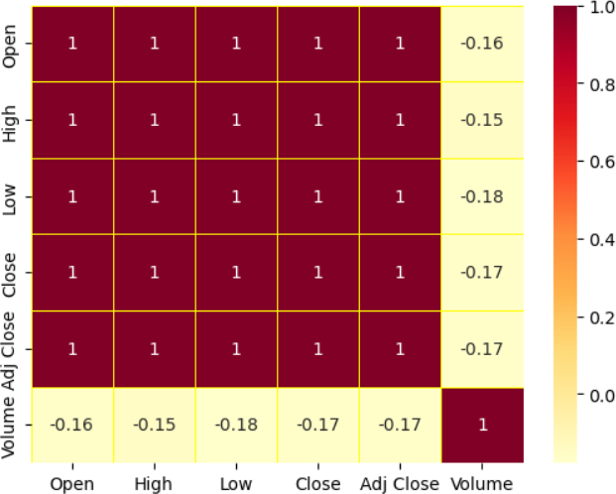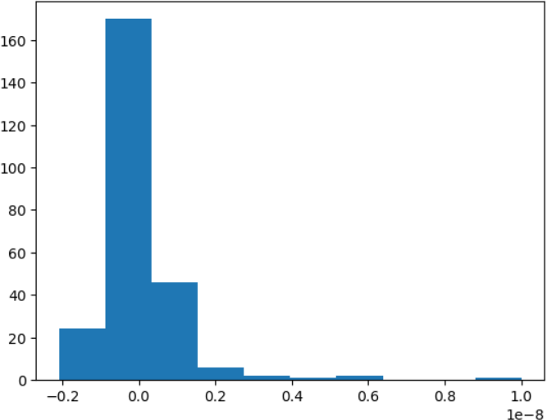

## MULTIPLE LINEAR REGRESSION (WITHOUT LIBRARIES):

**CODE:**

import numpy as np

import matplotlib.pyplot as plt import seaborn as sns

import pandas as pd

def mean_squared_error(y_true, y_pred): return np.mean((y_true - y_pred) ** 2)

class CustomLinearRegression:

def init (self, learning_rate=0.01, epochs=1000): self.learning_rate = learning_rate

self.epochs = epochs

def fit(self, X, y):

self.m, self.n = X.shape self.weights = np.zeros(self.n) self.bias = 0

# Gradient Descent

for _ in range(self.epochs):

y_pred = np.dot(X, self.weights) + self.bias error = y_pred - y

# Compute Gradients

dw = (2 / self.m) * np.dot(X.T, error) db = (2 / self.m) * np.sum(error)

# Update Parameters

self.weights -= self.learning_rate * dw self.bias -= self.learning_rate * db

def predict(self, X):

return np.dot(X, self.weights) + self.bias

df = pd.read_csv("https://raw.githubusercontent.com/mwaskom/seaborn-data/master/iris.csv")

# Select features & target variable

X = df[['sepal_width', 'petal_length', 'petal_width']].values # Using 3 predictors y = df['sepal_length'].values # Predicting 'sepal_length'

# Normalize Features (Min-Max Scaling)

X = (X - X.min(axis=0)) / (X.max(axis=0) - X.min(axis=0))

# Split data into training and testing (80%-20%) split_ratio = 0.8

split_index = int(len(X) * split_ratio)

X_train, X_test = X[:split_index], X[split_index:] y_train, y_test = y[:split_index], y[split_index:]

mlr_custom = CustomLinearRegression(learning_rate=0.1, epochs=1000) mlr_custom.fit(X_train, y_train)

y_pred_custom = mlr_custom.predict(X_test)

# Evaluate Model

mse = mean_squared_error(y_test, y_pred_custom) print(f"Custom Multi Linear Regression MSE: {mse:.4f}")

plt.figure(figsize=(6, 5))

plt.scatter(y_test, y_pred_custom, color='blue', edgecolors='k', alpha=0.7)

plt.plot([min(y_test), max(y_test)], [min(y_test), max(y_test)], color='red', linestyle='dashed') plt.xlabel("Actual Values")

plt.ylabel("Predicted Values")

plt.title("Actual vs Predicted Values (Custom Multi Linear Regression)") plt.show()

residuals = y_test - y_pred_custom plt.figure(figsize=(6, 5))

plt.scatter(y_pred_custom, residuals, color='purple', edgecolors='k', alpha=0.7) plt.axhline(y=0, color='red', linestyle='dashed')

plt.xlabel("Predicted Values") plt.ylabel("Residuals")

plt.title("Residual Plot (Custom Multi Linear Regression)") plt.show()

feature_names = ['sepal_width', 'petal_length', 'petal_width'] coefficients = mlr_custom.weights

plt.figure(figsize=(6, 5))

sns.barplot(x=feature_names, y=coefficients, palette="viridis") plt.xlabel("Features")

plt.ylabel("Coefficient Value")

plt.title("Feature Importance in Custom Multi Linear Regression") plt.xticks(rotation=45)

plt.show()

**CODE OUTPUT:**

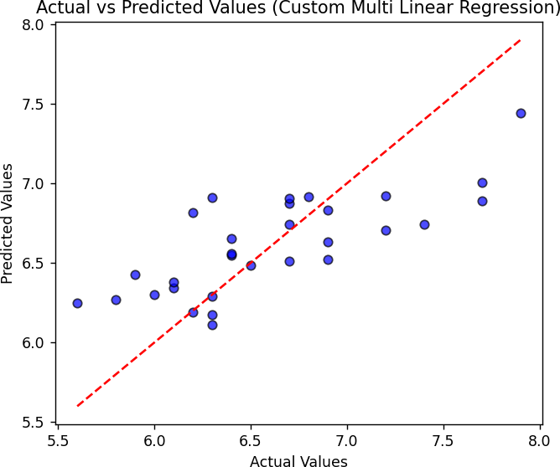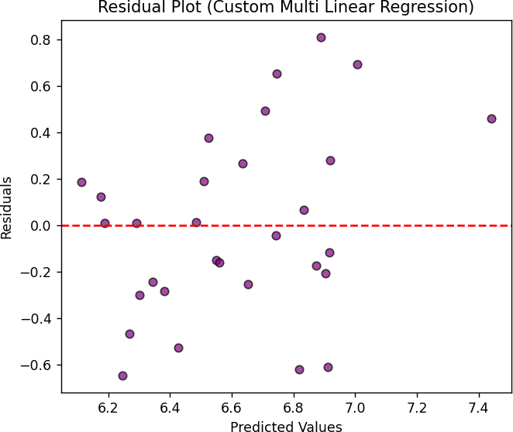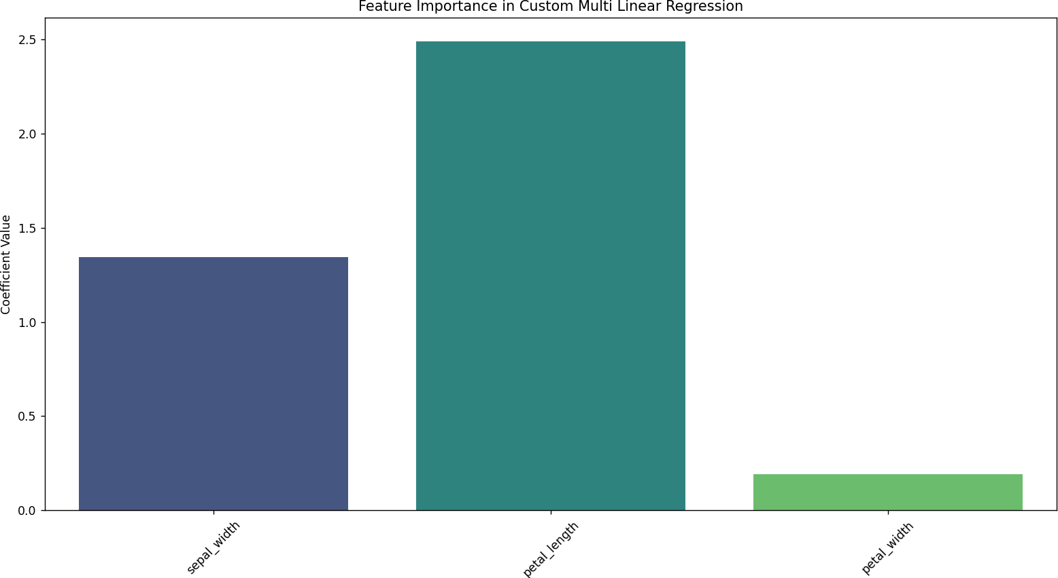

**LEARNING OUTCOME:**

# EXPERIMENT 4

**AIM:** Write a program for performing logistic regression using and without using libraries.

**THEORY:**

## LOGISTIC REGRESSION (WITH LIBRARIES):

**CODE:**

import pandas as pd

import matplotlib.pyplot as plt import numpy as np

import seaborn as sns

df = pd.read_csv("apple_quality.csv") df.head()

df.describe() df.info()

df.dropna(inplace=True) df.info()

type(df['Acidity'])

#‘coerce’ will set invalid parsing as NaN

df['Acidity']=pd.to_numeric(df['Acidity'], errors='coerce') df.info()

#df.isna().any(axis=1) df.dropna(inplace=True)

df1 = df[df.isna().any(axis=1)] df2 = df.drop('A_id',axis=1) df2.describe()

sns.heatmap(df2.drop('Quality',axis=1).corr(),cmap='YlOrRd',annot=True,linewidth=0.5,linecolor='Yel low')

sns.pairplot(df2)

sns.pairplot(df2,hue='Quality')

df.Quality = df2.Quality.replace({'good':1,'bad':0}) df2.head()

from sklearn.model_selection import train_test_split from sklearn.linear_model import LogisticRegression from sklearn import metrics

X = df2.drop('Quality', axis=1)

Y = df2['Quality']

X_train, X_test, Y_train, Y_test = train_test_split(X, Y, test_size=0.25, random_state=0) reg = LogisticRegression()

reg.fit(X_train, Y_train) Y_pred = reg.predict(X_test)

confusion_matrix = metrics.confusion_matrix(Y_test, Y_pred) print(confusion_matrix)

sns.heatmap(confusion_matrix, cmap='YlGnBu', annot=True, fmt='g') metrics.accuracy_score(Y_pred, Y_test)

metrics.precision_score(Y_test, Y_pred) metrics.f1_score(Y_test, Y_pred)

metrics.recall_score(Y_test, Y_pred)

**CODE OUTPUT:**

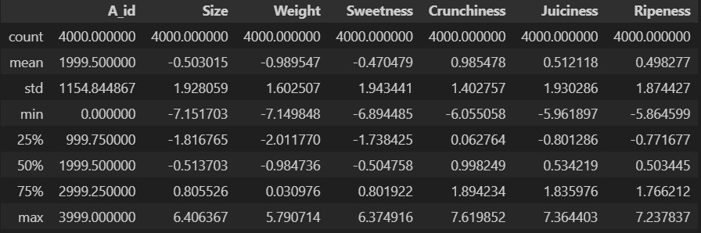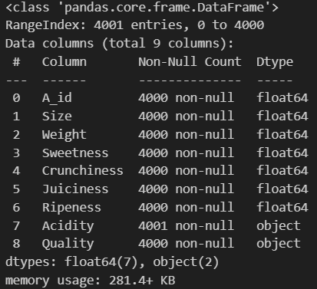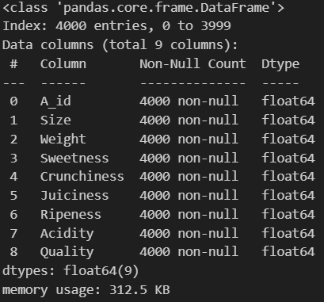

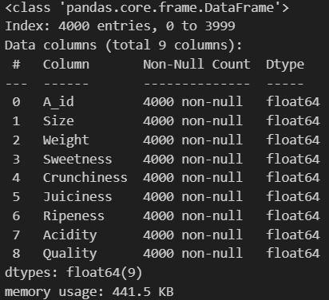 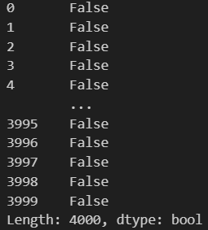

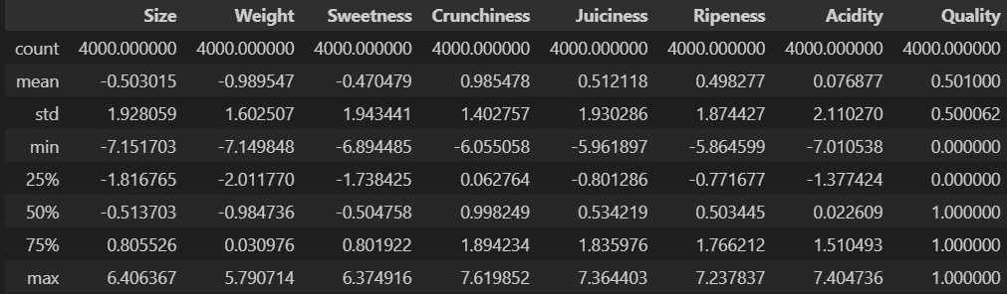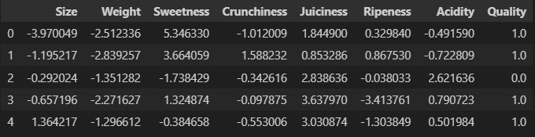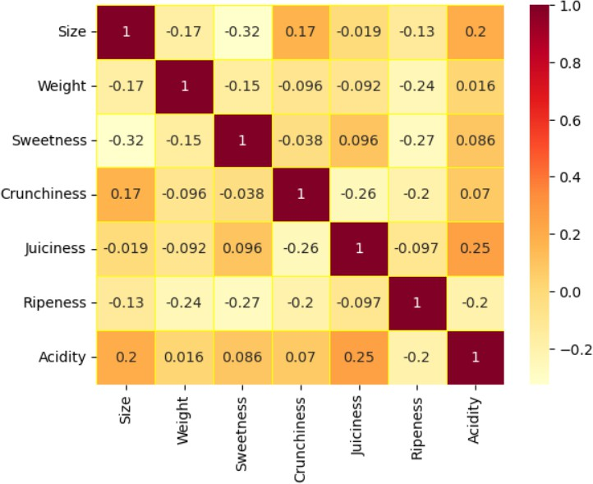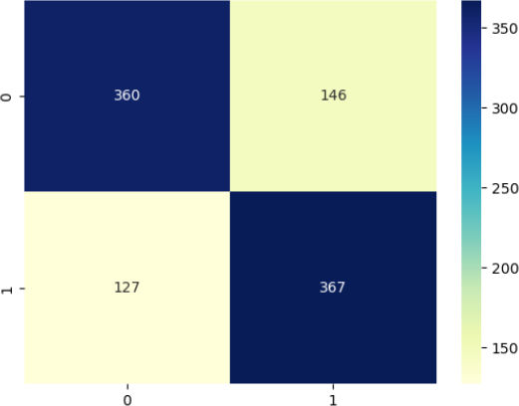

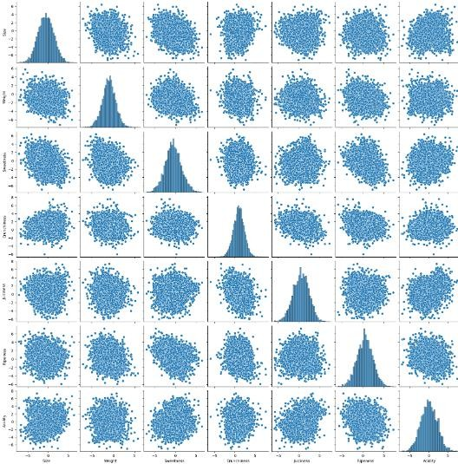 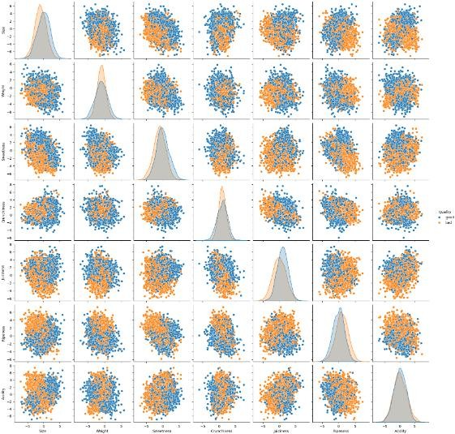

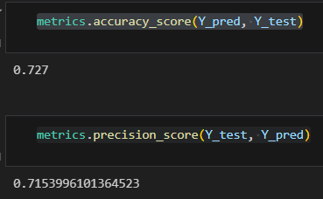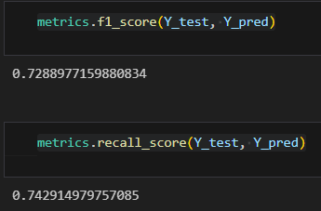

## LOGISTIC REGRESSION (WITHOUT LIBRARIES):

**CODE:**

import numpy as np

import matplotlib.pyplot as plt import seaborn as sns

import pandas as pd

def sigmoid(z):

return 1 / (1 + np.exp(-z))

class CustomLogisticRegression:

def init (self, learning_rate=0.01, epochs=1000): self.learning_rate = learning_rate

self.epochs = epochs

def fit(self, X, y):

self.m, self.n = X.shape self.weights = np.zeros(self.n) self.bias = 0

# Gradient Descent

for _ in range(self.epochs):

model = np.dot(X, self.weights) + self.bias predictions = sigmoid(model)

# Compute Gradients

dw = (1 / self.m) * np.dot(X.T, (predictions - y)) db = (1 / self.m) * np.sum(predictions - y)

# Update Parameters

self.weights -= self.learning_rate * dw self.bias -= self.learning_rate * db

def predict(self, X):

model = np.dot(X, self.weights) + self.bias predictions = sigmoid(model)

return [1 if p > 0.5 else 0 for p in predictions]

df = pd.read_csv("https://raw.githubusercontent.com/mwaskom/seaborn-data/master/iris.csv")

# Convert categorical target ('species') into numeric

df = df[df['species'] != 'virginica'] # Binary classification (Setosa vs. Versicolor)

df['species'] = df['species'].astype('category').cat.codes # 0: Setosa, 1: Versicolor

# Select features (using first 2 for visualization)

X = df[['sepal_length', 'sepal_width']].values y = df['species'].values

# Split data into training and testing (80%-20%)

split_ratio = 0.8

split_index = int(len(X) * split_ratio)

X_train, X_test = X[:split_index], X[split_index:] y_train, y_test = y[:split_index], y[split_index:]

log_reg_custom = CustomLogisticRegression(learning_rate=0.1, epochs=1000) log_reg_custom.fit(X_train, y_train)

y_pred_custom = log_reg_custom.predict(X_test)

# Calculate accuracy

accuracy = np.mean(y_pred_custom == y_test)

print("Custom Logistic Regression Accuracy:", accuracy)

def plot_decision_boundary(model, X, y):

x_min, x_max = X[:, 0].min() - 1, X[:, 0].max() + 1

y_min, y_max = X[:, 1].min() - 1, X[:, 1].max() + 1

xx, yy = np.meshgrid(np.linspace(x_min, x_max, 100), np.linspace(y_min, y_max, 100))

# Predict on grid points

Z = model.predict(np.c_[xx.ravel(), yy.ravel()]) Z = np.array(Z).reshape(xx.shape)

plt.contourf(xx, yy, Z, alpha=0.3, cmap='coolwarm')

scatter = plt.scatter(X[:, 0], X[:, 1], c=y, edgecolor='k', cmap='coolwarm') plt.xlabel("Feature 1")

plt.ylabel("Feature 2")

plt.title("Logistic Regression Decision Boundary (Custom Implementation)") plt.legend(*scatter.legend_elements(), title="Classes")

plt.show()

plot_decision_boundary(log_reg_custom, X_train, y_train)

def plot_confusion_matrix(y_true, y_pred): cm = np.zeros((2, 2), dtype=int)

for true, pred in zip(y_true, y_pred):

cm[true][pred] += 1

plt.figure(figsize=(6, 5))

sns.heatmap(cm, annot=True, fmt="d", cmap="Blues", xticklabels=['Setosa', 'Versicolor'], yticklabels=['Setosa', 'Versicolor'])

plt.xlabel('Predicted') plt.ylabel('Actual')

plt.title('Confusion Matrix for Custom Logistic Regression') plt.show()

plot_confusion_matrix(y_test, y_pred_custom)

**CODE OUTPUT:**

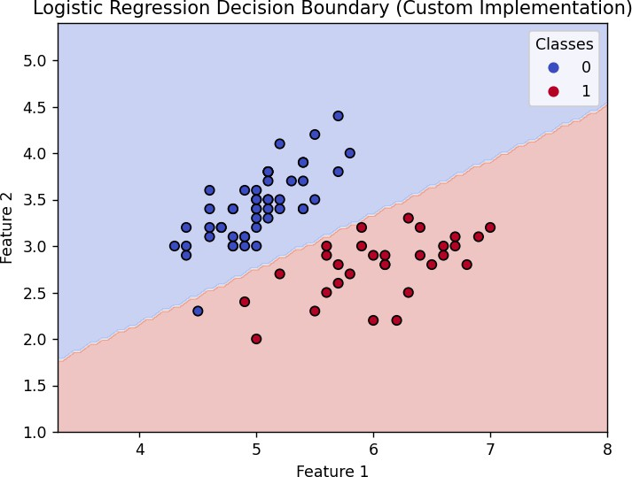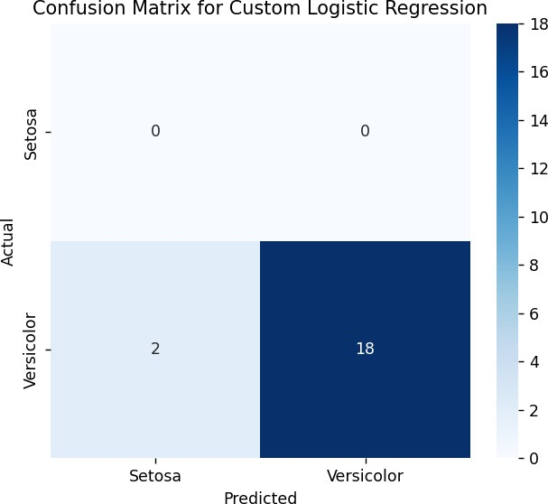

**LEARNING OUTCOME:**

# EXPERIMENT 5

**AIM:** Write a program for performing KNN using and without using libraries.

**THEORY:**

## KNN (WITH LIBRARIES):

**CODE:**

import numpy as np import pandas as pd

import matplotlib.pyplot as plt import seaborn as sns

from sklearn.model_selection import train_test_split from sklearn.neighbors import KNeighborsClassifier

from sklearn.metrics import accuracy_score, confusion_matrix

df = pd.read_csv("https://raw.githubusercontent.com/mwaskom/seaborn-data/master/iris.csv")

# Convert categorical target ('species') into numeric

df['species'] = df['species'].astype('category').cat.codes # 0: setosa, 1: versicolor, 2: virginica

# Select features (using first 2 for visualization)

X = df[['sepal_length', 'sepal_width']].values y = df['species'].values

# Split data into training and testing (80%-20%)

X_train, X_test, y_train, y_test = train_test_split(X, y, test_size=0.2, random_state=42)

knn = KNeighborsClassifier(n_neighbors=5) knn.fit(X_train, y_train)

y_pred_knn = knn.predict(X_test)

# Evaluate

accuracy = accuracy_score(y_test, y_pred_knn) print("KNN (sklearn) Accuracy:", accuracy)

def plot_decision_boundary(model, X, y):

x_min, x_max = X[:, 0].min() - 1, X[:, 0].max() + 1

y_min, y_max = X[:, 1].min() - 1, X[:, 1].max() + 1

xx, yy = np.meshgrid(np.linspace(x_min, x_max, 100), np.linspace(y_min, y_max, 100))

# Predict on grid points

Z = model.predict(np.c_[xx.ravel(), yy.ravel()]) Z = Z.reshape(xx.shape)

plt.contourf(xx, yy, Z, alpha=0.3)

scatter = plt.scatter(X[:, 0], X[:, 1], c=y, edgecolor='k') plt.xlabel("Feature 1")

plt.ylabel("Feature 2")

plt.title("KNN Decision Boundary (sklearn)")

plt.legend(*scatter.legend_elements(), title="Classes") plt.show()

plot_decision_boundary(knn, X_train, y_train)

cm = confusion_matrix(y_test, y_pred_knn) plt.figure(figsize=(6, 5))

sns.heatmap(cm, annot=True, fmt="d", cmap="Blues", xticklabels=['Setosa', 'Versicolor', 'Virginica'], yticklabels=['Setosa', 'Versicolor', 'Virginica'])

plt.xlabel('Predicted') plt.ylabel('Actual')

plt.title('Confusion Matrix for KNN (sklearn)') plt.show()

**CODE OUTPUT:**

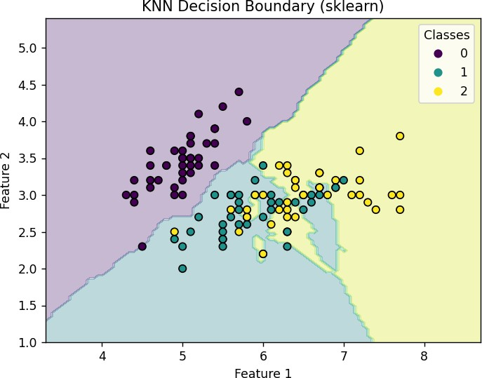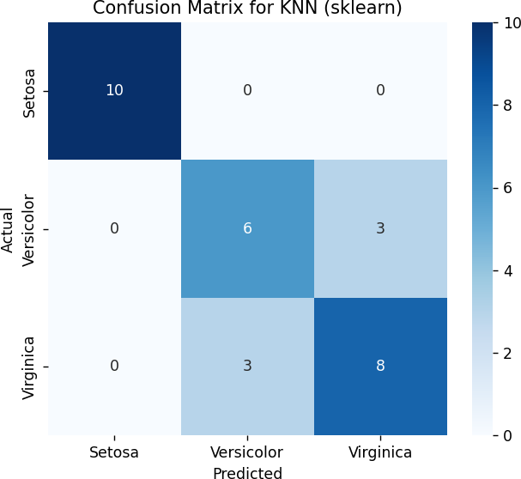

## KNN (WITHOUT LIBRARIES):

**CODE:**

import numpy as np

import matplotlib.pyplot as plt import seaborn as sns

from collections import Counter

def euclidean_distance(x1, x2):

return np.sqrt(np.sum((x1 - x2) ** 2))

class CustomKNN:

def init (self, k=3):

self.k = k

def fit(self, X_train, y_train):

self.X_train = X_train self.y_train = y_train

def predict(self, X_test):

predictions = [self._predict(x) for x in X_test]

return np.array(predictions)

def _predict(self, x):

# Compute distances

distances = [euclidean_distance(x, x_train) for x_train in self.X_train] # Get k nearest labels

k_indices = np.argsort(distances)[:self.k]

k_nearest_labels = [self.y_train[i] for i in k_indices] # Majority vote

most_common = Counter(k_nearest_labels).most_common(1) return most_common[0][0]

import pandas as pd

from sklearn.model_selection import train_test_split

from sklearn.metrics import confusion_matrix, accuracy_score

df = pd.read_csv("https://raw.githubusercontent.com/mwaskom/seaborn-data/master/iris.csv")

# Convert categorical target ('species') into numeric

df['species'] = df['species'].astype('category').cat.codes # 0: setosa, 1: versicolor, 2: virginica

# Select features (using first 2 for visualization)

X = df[['sepal_length', 'sepal_width']].values y = df['species'].values

# Split data into training and testing (80%-20%)

X_train, X_test, y_train, y_test = train_test_split(X, y, test_size=0.2, random_state=42)

knn_custom = CustomKNN(k=5) knn_custom.fit(X_train, y_train)

y_pred_custom = knn_custom.predict(X_test)

# Evaluate

accuracy_custom = accuracy_score(y_test, y_pred_custom) print("Custom KNN Accuracy:", accuracy_custom)

def plot_decision_boundary(model, X, y):

x_min, x_max = X[:, 0].min() - 1, X[:, 0].max() + 1

y_min, y_max = X[:, 1].min() - 1, X[:, 1].max() + 1

xx, yy = np.meshgrid(np.linspace(x_min, x_max, 100), np.linspace(y_min, y_max, 100))

# Predict on grid points

Z = np.array([model._predict(np.array([a, b])) for a, b in zip(xx.ravel(), yy.ravel())]) Z = Z.reshape(xx.shape)

plt.contourf(xx, yy, Z, alpha=0.3)

scatter = plt.scatter(X[:, 0], X[:, 1], c=y, edgecolor='k') plt.xlabel("Feature 1")

plt.ylabel("Feature 2")

plt.title("KNN Decision Boundary (Custom Implementation)") plt.legend(*scatter.legend_elements(), title="Classes") plt.show()

plot_decision_boundary(knn_custom, X_train, y_train)

cm = confusion_matrix(y_test, y_pred_custom) plt.figure(figsize=(6, 5))

sns.heatmap(cm, annot=True, fmt="d", cmap="Blues", xticklabels=['Setosa', 'Versicolor', 'Virginica'], yticklabels=['Setosa', 'Versicolor', 'Virginica'])

plt.xlabel('Predicted') plt.ylabel('Actual')

plt.title('Confusion Matrix for Custom KNN') plt.show()

**CODE OUTPUT:**

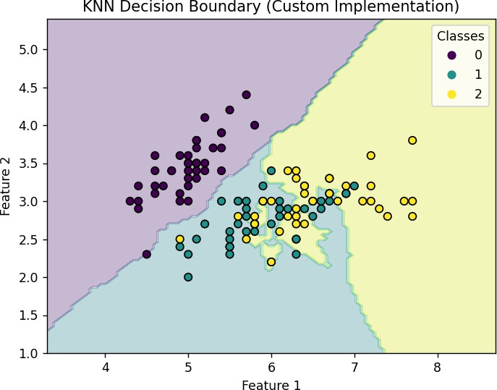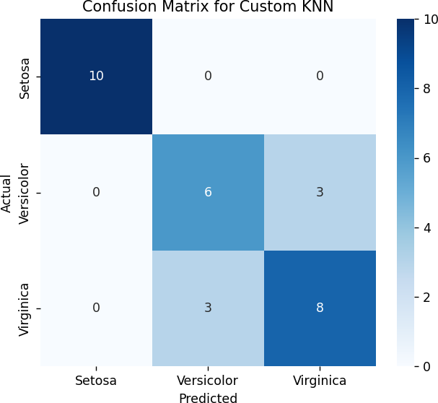

**LEARNING OUTCOME:**

# EXPERIMENT 6

**AIM:** Write a program to Implement classification using SVM using library and without using library

**THEORY:**

## SVM (WITH LIBRARIES):

**CODE:**

# Import required libraries import numpy as np

import pandas as pd

import matplotlib.pyplot as plt import seaborn as sns

from sklearn import datasets

from sklearn.model_selection import train_test_split from sklearn.svm import SVC

from sklearn.metrics import accuracy_score, classification_report, confusion_matrix

# Load the dataset

iris = datasets.load_iris()

df = pd.DataFrame(iris.data, columns=iris.feature_names) df['target'] = iris.target # Add the target column

df['species'] = df['target'].map({0: 'Setosa', 1: 'Versicolor', 2: 'Virginica'}) # Map to class names

# Display first 5 rows

print("First 5 rows of dataset:") print(df.head())

# Data Visualization - Pairplot

sns.pairplot(df, hue="species", diag_kind="kde", palette="husl") plt.show()

# Correlation Heatmap plt.figure(figsize=(8,6))

sns.heatmap(df.corr(), annot=True, cmap='coolwarm', fmt=".2f") plt.title("Feature Correlation Heatmap")

plt.show()

# Split data into train & test sets

X = df.iloc[:, :-2] # Features (excluding target & species columns) y = df['target'] # Target labels

X_train, X_test, y_train, y_test = train_test_split(X, y, test_size=0.3, random_state=42)

# Train SVM model

svm_model = SVC(kernel='linear', C=1.0) # Linear kernel svm_model.fit(X_train, y_train)

# Predictions

y_pred = svm_model.predict(X_test)

# Model Evaluation

accuracy = accuracy_score(y_test, y_pred)

print("\nModel Accuracy: {:.2f}%".format(accuracy * 100))

print("\nClassification Report:\n", classification_report(y_test, y_pred))

# Confusion Matrix Visualization

conf_matrix = confusion_matrix(y_test, y_pred) plt.figure(figsize=(6,4))

sns.heatmap(conf_matrix, annot=True, cmap="Blues", fmt='d',

xticklabels=iris.target_names, yticklabels=iris.target_names) plt.xlabel("Predicted Label")

plt.ylabel("True Label") plt.title("Confusion Matrix") plt.show()

**CODE OUTPUT:**

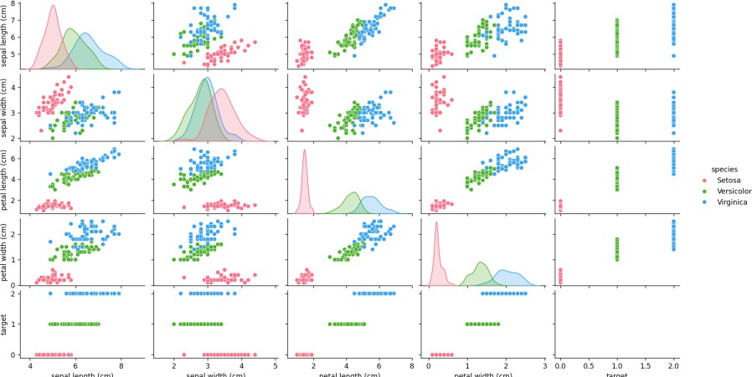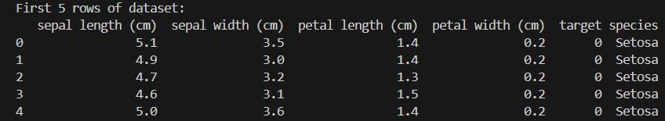

## SVM (WITHOUT LIBRARIES):

**CODE:**

import numpy as np

import matplotlib.pyplot as plt import seaborn as sns

from sklearn.datasets import make_blobs

from sklearn.model_selection import train_test_split

# Generate synthetic dataset

X, y = make_blobs(n_samples=100, centers=2, random_state=42, cluster_std=1.5) y = np.where(y == 0, -1, 1) # Convert labels from {0,1} to {-1,1}

# Split into training and testing sets

X_train, X_test, y_train, y_test = train_test_split(X, y, test_size=0.3, random_state=42)

# Visualizing the data plt.figure(figsize=(8,6))

sns.scatterplot(x=X_train[:, 0], y=X_train[:, 1], hue=y_train, palette={-1: 'red', 1: 'blue'}) plt.title("Training Data Distribution")

plt.show()

# SVM Model from Scratch class SVM:

def init (self, learning_rate=0.001, lambda_param=0.01, epochs=1000): self.lr = learning_rate

self.lambda_param = lambda_param self.epochs = epochs

self.w = None self.b = None

def fit(self, X, y):

n_samples, n_features = X.shape

self.w = np.zeros(n_features) # Initialize weights self.b = 0 # Initialize bias

for _ in range(self.epochs):

for i, x_i in enumerate(X):

condition = y[i] * (np.dot(x_i, self.w) + self.b) >= 1 if condition:

self.w -= self.lr * (2 * self.lambda_param * self.w) else:

self.w -= self.lr * (2 * self.lambda_param * self.w - np.dot(x_i, y[i])) self.b -= self.lr * y[i]

def predict(self, X):

return np.sign(np.dot(X, self.w) + self.b)

# Train SVM Model

svm = SVM() svm.fit(X_train, y_train)

# Predictions

y_pred = svm.predict(X_test)

# Accuracy Calculation

accuracy = np.mean(y_pred == y_test)

print(f"Model Accuracy: {accuracy * 100:.2f}%")

# Visualizing Decision Boundary

def plot_decision_boundary(X, y, model):

fig, ax = plt.subplots(figsize=(8,6))

sns.scatterplot(x=X[:, 0], y=X[:, 1], hue=y, palette={-1: 'red', 1: 'blue'}, edgecolor='k')

x_min, x_max = X[:, 0].min() - 1, X[:, 0].max() + 1

y_min, y_max = X[:, 1].min() - 1, X[:, 1].max() + 1

xx, yy = np.meshgrid(np.linspace(x_min, x_max, 50), np.linspace(y_min, y_max, 50)) Z = model.predict(np.c_[xx.ravel(), yy.ravel()])

Z = Z.reshape(xx.shape)

ax.contourf(xx, yy, Z, alpha=0.2, colors=['red', 'blue']) ax.set_title("SVM Decision Boundary")

plt.show()

# Plot the decision boundary plot_decision_boundary(X_test, y_test, svm)

**CODE OUTPUT:**

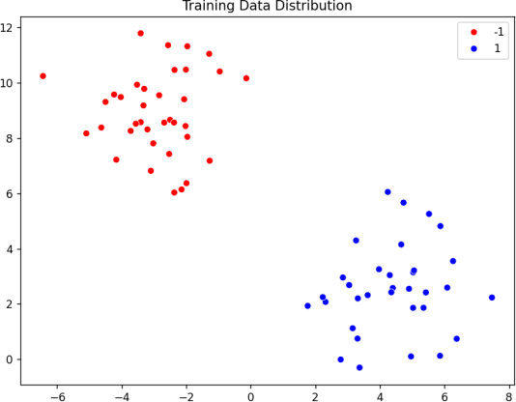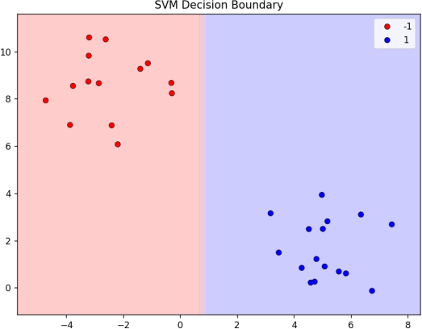

**LEARNING OUTCOME:**

# EXPERIMENT 7

**AIM:** Write a program for performing bagging using random forest with and without using libraries.

**THEORY:**

## RANDOM FOREST (WITH LIBRARIES):

**CODE:**

import numpy as np

import matplotlib.pyplot as plt

from sklearn.datasets import load_iris

from sklearn.model_selection import train_test_split

from sklearn.ensemble import RandomForestClassifier from sklearn.metrics import accuracy_score

from matplotlib.colors import ListedColormap from sklearn.datasets import load_iris

# Load the Iris dataset iris = load_iris()

X = iris.data[:, :2] # Use only 2 features for visualization y = iris.target # Extract target labels

X_train, X_test, y_train, y_test = train_test_split(X, y, test_size=0.2, random_state=42)

# Train Random Forest model

rf_model = RandomForestClassifier(n_estimators=10, max_depth=5, bootstrap=True, random_state=42)

rf_model.fit(X_train, y_train)

# Make predictions

y_pred = rf_model.predict(X_test)

# Evaluate model performance

accuracy = accuracy_score(y_test, y_pred)

print(f"Random Forest Accuracy (with library): {accuracy:.4f}")

# Function to plot decision boundaries

def plot_decision_boundary(model, X, y, title):

x_min, x_max = X[:, 0].min() - 1, X[:, 0].max() + 1

y_min, y_max = X[:, 1].min() - 1, X[:, 1].max() + 1

xx, yy = np.meshgrid(np.linspace(x_min, x_max, 100), np.linspace(y_min, y_max, 100))

Z = model.predict(np.c_[xx.ravel(), yy.ravel()]) Z = Z.reshape(xx.shape)

cmap_light = ListedColormap(["#FFAAAA", "#AAFFAA", "#AAAAFF"]) cmap_bold = ListedColormap(["#FF0000", "#00FF00", "#0000FF"]) plt.figure(figsize=(8, 6))

plt.contourf(xx, yy, Z, alpha=0.3, cmap=cmap_light)

plt.scatter(X[:, 0], X[:, 1], c=y, cmap=cmap_bold, edgecolor='k') plt.title(title)

plt.xlabel("Feature 1")

plt.ylabel("Feature 2") plt.show()

# Plot the decision boundary of the Random Forest

plot_decision_boundary(rf_model, X_train, y_train, "Random Forest Decision Boundary (With Library)")

**CODE OUTPUT:**

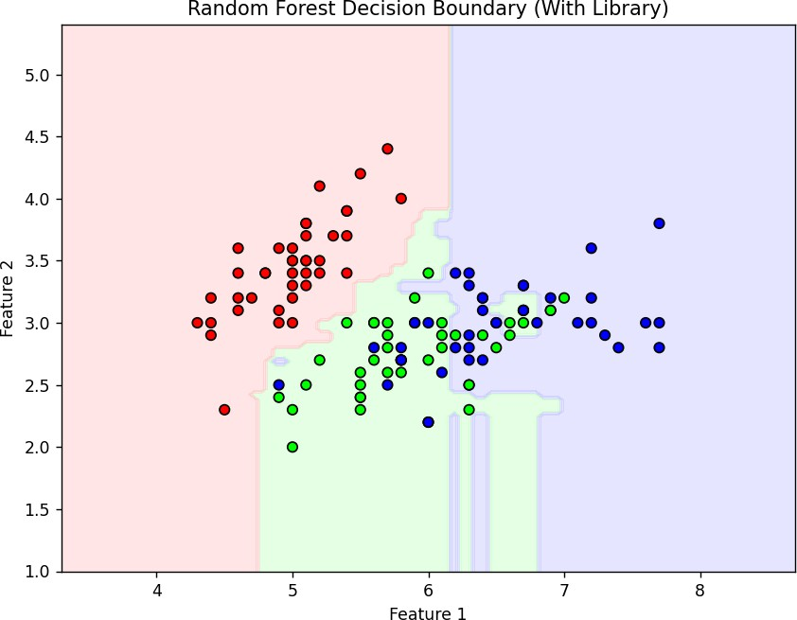

## RANDOM FOREST (WITHOUT LIBRARIES):

**CODE:**

import numpy as np

import matplotlib.pyplot as plt

from sklearn.tree import DecisionTreeClassifier from sklearn.datasets import load_iris

from sklearn.model_selection import train_test_split from sklearn.metrics import accuracy_score

from matplotlib.colors import ListedColormap from sklearn.datasets import load_iris

iris = load_iris()

X = iris.data[:, :2] # Use only 2 features for visualization y = iris.target # Extract target labels

X_train, X_test, y_train, y_test = train_test_split(X, y, test_size=0.2, random_state=42)

# Bagging Parameters

n_estimators = 10 # Number of decision trees

bootstrap_size = int(0.8 * len(X_train)) # 80% samples in each bootstrap

# Initialize list to store models trees = []

# Train multiple decision trees using bootstrap samples for _ in range(n_estimators):

indices = np.random.choice(len(X_train), bootstrap_size, replace=True) X_bootstrap, y_bootstrap = X_train[indices], y_train[indices]

tree = DecisionTreeClassifier(max_depth=5) tree.fit(X_bootstrap, y_bootstrap)

trees.append(tree)

# Make predictions using majority voting

predictions = np.array([tree.predict(X_test) for tree in trees])

y_pred = np.apply_along_axis(lambda x: np.bincount(x).argmax(), axis=0, arr=predictions)

# Evaluate model performance

accuracy = accuracy_score(y_test, y_pred)

print(f"Bagging with Decision Trees Accuracy (without library): {accuracy:.4f}")

# Function to plot decision boundaries for an ensemble of trees def plot_decision_boundary_ensemble(models, X, y, title):

x_min, x_max = X[:, 0].min() - 1, X[:, 0].max() + 1

y_min, y_max = X[:, 1].min() - 1, X[:, 1].max() + 1

xx, yy = np.meshgrid(np.linspace(x_min, x_max, 100), np.linspace(y_min, y_max, 100))

# Aggregate predictions from all trees

pred_votes = np.zeros((xx.shape[0] * xx.shape[1], len(models))) for i, tree in enumerate(models):

pred_votes[:, i] = tree.predict(np.c_[xx.ravel(), yy.ravel()])

# Perform majority voting

final_preds = np.apply_along_axis(lambda x: np.bincount(x.astype(int)).argmax(), axis=1, arr=pred_votes) Z = final_preds.reshape(xx.shape)

cmap_light = ListedColormap(["#FFAAAA", "#AAFFAA", "#AAAAFF"]) cmap_bold = ListedColormap(["#FF0000", "#00FF00", "#0000FF"])

plt.figure(figsize=(8, 6))

plt.contourf(xx, yy, Z, alpha=0.3, cmap=cmap_light)

plt.scatter(X[:, 0], X[:, 1], c=y, cmap=cmap_bold, edgecolor='k') plt.title(title)

plt.xlabel("Feature 1")

plt.ylabel("Feature 2") plt.show()

# Plot the decision boundary of the Bagging Classifier

plot_decision_boundary_ensemble(trees, X_train, y_train, "Bagging with Decision Trees Decision Boundary (Without Library)")

**CODE OUTPUT:**



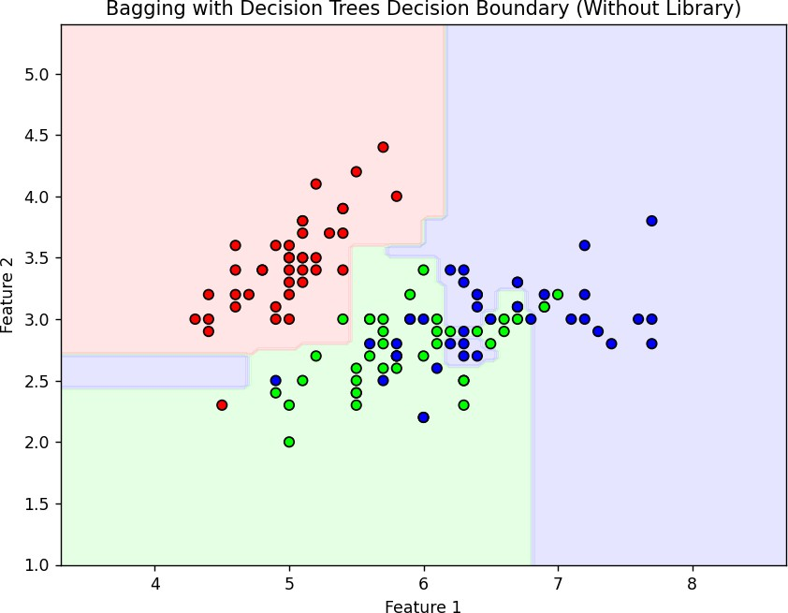

**LEARNING OUTCOME:**

# EXPERIMENT 8

**AIM:** Write a program to Implement Naïve Bayes using library and without using library

**THEORY:**

## NAÏVE BAYES (WITH LIBRARIES):

**CODE:**

from sklearn.model_selection import train_test_split from sklearn.naive_bayes import GaussianNB

from sklearn.preprocessing import StandardScaler from sklearn.metrics import accuracy_score

from sklearn.datasets import make_classification from collections import Counter

# Generate synthetic dataset with 1000 samples and 2 features

X, y = make_classification(n_samples=1000, n_features=2, n_informative=2, n_redundant=0, n_clusters_per_class=1, random_state=42)

# Split data into training and testing sets (80% train, 20% test)

X_train, X_test, y_train, y_test = train_test_split(X, y, test_size=0.2, random_state=42, stratify=y)

# Print class distributions in the training and testing set print(f"Class distribution in training set: {Counter(y_train)}") print(f"Class distribution in testing set: {Counter(y_test)}")

# Feature scaling using StandardScaler scaler = StandardScaler()

# Scale the training and testing data

X_train_scaled = scaler.fit_transform(X_train) X_test_scaled = scaler.transform(X_test)

# Initialize the Gaussian Naive Bayes classifier nb = GaussianNB()

# Train the model on the scaled data

nb.fit(X_train_scaled, y_train)

# Predict on the test data

y_pred_scaled = nb.predict(X_test_scaled)

# Calculate accuracy

accuracy_scaled = accuracy_score(y_test, y_pred_scaled)

print(f'Accuracy of Naive Bayes classifier (scaled data): {accuracy_scaled * 100:.2f}%')

**CODE OUTPUT:**



## NAÏVE BAYES (WITHOUT LIBRARIES):

**CODE:**

import numpy as np

# Sample data (expanded dataset from earlier, you can replace this with your data) X_train = np.array([[1.1, 2.0], [1.9, 3.2], [2.3, 1.5], [3.1, 4.4], [1.5, 2.3], [3.0, 3.5],

[2.5, 3.5], [1.8, 2.5], [2.0, 2.8], [3.0, 3.0], [2.1, 2.9], [1.7, 2.4],

[2.9, 3.3], [3.5, 4.1], [1.3, 2.2], [3.2, 3.6], [2.8, 2.6], [1.6, 2.1],

[2.2, 2.3], [3.3, 3.8], [1.4, 2.7], [3.4, 4.0], [2.6, 3.4], [2.7, 2.5],

[2.4, 3.2], [1.2, 2.5], [3.0, 3.2], [1.0, 2.1], [2.8, 3.0], [1.9, 2.7],

[2.3, 3.1], [3.1, 3.7], [1.8, 2.3], [2.7, 3.6], [1.5, 2.4], [3.0, 3.5],

[2.2, 3.0], [2.9, 3.8], [3.2, 4.4], [1.4, 2.2], [1.6, 2.8], [2.6, 2.7],

[3.3, 4.0], [2.1, 2.5], [3.4, 3.9], [2.0, 2.2], [1.7, 2.6], [2.5, 3.3]])

y_train = np.array([0, 0, 1, 1, 0, 1, 1, 0, 1, 1, 0, 0, 1, 1, 0, 1, 1, 0, 0, 1, 0, 1, 0, 1,

0, 1, 0, 1, 1, 0, 1, 0, 1, 1, 0, 1, 0, 1, 0, 1, 1, 0, 0, 1, 1, 0, 0, 1])

# Test data (small test set for demonstration)

X_test = np.array([[2.1, 2.8], [1.7, 2.6], [2.8, 3.5], [3.0, 3.3], [2.2, 2.4], [1.8, 2.1]])

y_test = np.array([1, 0, 1, 1, 0, 1]) # Actual labels

# Naive Bayes function (for simplicity, assume Gaussian Naive Bayes) def naive_bayes(X_train, y_train, X_test):

# Calculating prior probabilities classes = np.unique(y_train)

prior_probs = {class_val: np.mean(y_train == class_val) for class_val in classes}

# Calculating likelihoods (Gaussian distributions) likelihoods = {}

for class_val in classes:

X_class = X_train[y_train == class_val] mean = X_class.mean(axis=0)

std = X_class.std(axis=0)

likelihoods[class_val] = (mean, std)

# Making predictions for test data predictions = []

for x in X_test:

# Calculate the posterior probability for each class posteriors = {}

for class_val in classes:

mean, std = likelihoods[class_val]

likelihood = np.prod((1 / (std * np.sqrt(2 * np.pi))) * np.exp(-0.5 * ((x - mean) / std) ** 2)) posterior = prior_probs[class_val] * likelihood

posteriors[class_val] = posterior

# Predict the class with the highest posterior probability predicted_class = max(posteriors, key=posteriors.get)

predictions.append(predicted_class)

return np.array(predictions)

# Get predictions

predictions = naive_bayes(X_train, y_train, X_test)

# Calculate accuracy

accuracy = np.mean(predictions == y_test) * 100

print(f"Predictions from Naive Bayes (from scratch): {predictions}") print(f"Accuracy: {accuracy:.2f}%")

**CODE OUTPUT:**



**LEARNING OUTCOME:**

# EXPERIMENT 9

**AIM:** Write a program for performing decision trees using and without using libraries.

**THEORY:**

## DECISION TREES (WITH LIBRARIES):

**CODE:**

import numpy as np import pandas as pd

import matplotlib.pyplot as plt import seaborn as sns

from sklearn.model_selection import train_test_split

from sklearn.tree import DecisionTreeClassifier, DecisionTreeRegressor, plot_tree from sklearn.metrics import accuracy_score, mean_squared_error

from matplotlib.colors import ListedColormap

df = pd.read_csv("https://raw.githubusercontent.com/mwaskom/seaborn-data/master/iris.csv")

# Convert categorical target ('species') into numeric

df['species'] = df['species'].astype('category').cat.codes # 0: Setosa, 1: Versicolor, 2: Virginica

X_cls = df[['sepal_length', 'sepal_width']].values # Using only two features for visualization y_cls = df['species'].values

# Split data

X_train_cls, X_test_cls, y_train_cls, y_test_cls = train_test_split(X_cls, y_cls, test_size=0.2, random_state=42)

# Train Decision Tree Classifier

clf = DecisionTreeClassifier(max_depth=4, random_state=42) clf.fit(X_train_cls, y_train_cls)

y_pred_cls = clf.predict(X_test_cls)

# Evaluate

accuracy = accuracy_score(y_test_cls, y_pred_cls) print(f"Decision Tree Classifier Accuracy: {accuracy:.4f}")

plt.figure(figsize=(12, 6))

plot_tree(clf, feature_names=['sepal_length', 'sepal_width'], class_names=['Setosa', 'Versicolor', 'Virginica'], filled=True)

plt.title("Decision Tree Visualization (Classification)") plt.show()

plt.figure(figsize=(6, 4))

sns.barplot(x=['sepal_length', 'sepal_width'], y=clf.feature_importances_, palette="coolwarm") plt.xlabel("Features")

plt.ylabel("Importance")

plt.title("Feature Importance in Decision Tree Classifier") plt.xticks(rotation=45)

plt.show()

x_min, x_max = X_cls[:, 0].min() - 1, X_cls[:, 0].max() + 1

y_min, y_max = X_cls[:, 1].min() - 1, X_cls[:, 1].max() + 1 xx, yy = np.meshgrid(np.arange(x_min, x_max, 0.02),

np.arange(y_min, y_max, 0.02))

Z = clf.predict(np.c_[xx.ravel(), yy.ravel()]) Z = Z.reshape(xx.shape)

plt.figure(figsize=(7, 5))

cmap = ListedColormap(["#FF9999", "#99FF99", "#9999FF"]) plt.contourf(xx, yy, Z, alpha=0.3, cmap=cmap)

scatter = plt.scatter(X_cls[:, 0], X_cls[:, 1], c=y_cls, cmap=cmap, edgecolor='k') plt.xlabel("Sepal Length")

plt.ylabel("Sepal Width")

plt.title("Decision Boundary (Classification)")

plt.legend(handles=scatter.legend_elements()[0], labels=['Setosa', 'Versicolor', 'Virginica'])

plt.show()

X_reg = df[['sepal_width', 'petal_length', 'petal_width']].values y_reg = df['sepal_length'].values

# Split data

X_train_reg, X_test_reg, y_train_reg, y_test_reg = train_test_split(X_reg, y_reg, test_size=0.2, random_state=42)

# Train Decision Tree Regressor

reg = DecisionTreeRegressor(max_depth=4, random_state=42) reg.fit(X_train_reg, y_train_reg)

y_pred_reg = reg.predict(X_test_reg)

# Evaluate

mse = mean_squared_error(y_test_reg, y_pred_reg) print(f"Decision Tree Regressor MSE: {mse:.4f}")

plt.figure(figsize=(6, 4))

sns.barplot(x=['sepal_width', 'petal_length', 'petal_width'], y=reg.feature_importances_, palette="viridis")

plt.xlabel("Features") plt.ylabel("Importance")

plt.title("Feature Importance in Decision Tree Regressor") plt.xticks(rotation=45)

plt.show()

**CODE OUTPUT:**

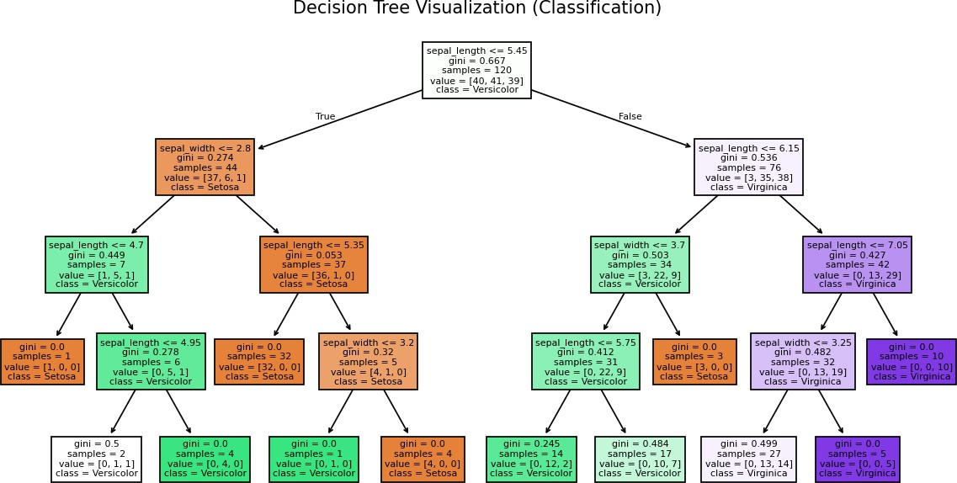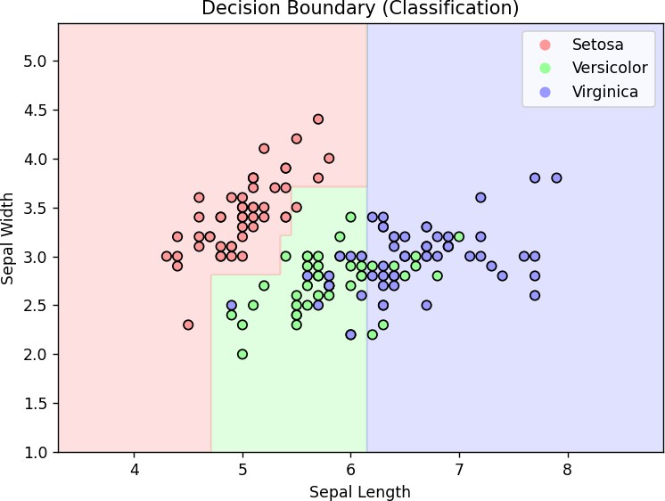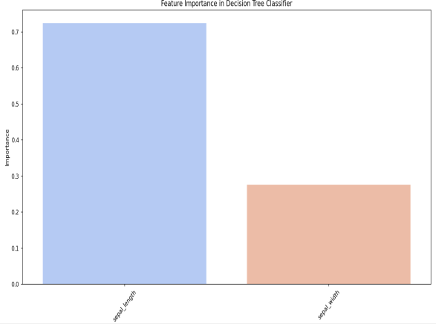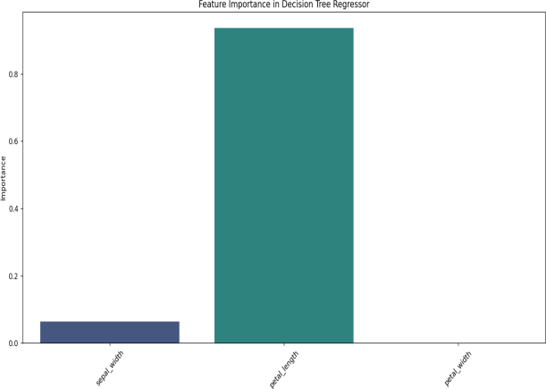

## DECISION TREES (WITHOUT LIBRARIES):

**CODE:**

import numpy as np import pandas as pd

import matplotlib.pyplot as plt import seaborn as sns

from matplotlib.colors import ListedColormap

#

# ‘’z Helper Functions for Decision Tree #

def gini_impurity(y):

"""Calculate Gini impurity for a set of labels.""" unique_classes, counts = np.unique(y, return_counts=True) probabilities = counts / len(y)

return 1 - np.sum(probabilities ** 2)

def best_split(X, y):

"""Find the best split by checking all possible thresholds for all features.""" best_feature, best_threshold, best_gain = None, None, 0

current_impurity = gini_impurity(y)

for feature_index in range(X.shape[1]): thresholds = np.unique(X[:, feature_index])

for threshold in thresholds:

left_mask = X[:, feature_index] <= threshold right_mask = ~left_mask

if np.sum(left_mask) == 0 or np.sum(right_mask) == 0:

continue

left_impurity = gini_impurity(y[left_mask])

right_impurity = gini_impurity(y[right_mask])

weighted_impurity = (np.sum(left_mask) * left_impurity + np.sum(right_mask) * right_impurity) / len(y)

gain = current_impurity - weighted_impurity

if gain > best_gain:

best_feature, best_threshold, best_gain = feature_index, threshold, gain

return best_feature, best_threshold

class DecisionTreeNode:

"""A single node in the Decision Tree."""

def init (self, feature=None, threshold=None, left=None, right=None, value=None): self.feature = feature

self.threshold = threshold self.left = left

self.right = right self.value = value

def is_leaf(self):

return self.value is not None

class DecisionTreeClassifierCustom: """Custom Decision Tree Classifier.""" def init (self, max_depth=5):

self.max_depth = max_depth self.tree = None

def fit(self, X, y, depth=0):

"""Recursively builds the decision tree."""

if len(set(y)) == 1: # If all labels are the same return DecisionTreeNode(value=y[0])

if depth >= self.max_depth or len(y) < 2: # Stopping criteria (FIXED ERROR) return DecisionTreeNode(value=np.bincount(y).argmax())

feature, threshold = best_split(X, y)

if feature is None:

return DecisionTreeNode(value=np.bincount(y).argmax())

left_mask = X[:, feature] <= threshold right_mask = ~left_mask

left_subtree = self.fit(X[left_mask], y[left_mask], depth + 1)

right_subtree = self.fit(X[right_mask], y[right_mask], depth + 1)

return DecisionTreeNode(feature, threshold, left_subtree, right_subtree)

def predict_one(self, x, node): """Predict a single sample.""" if node.is_leaf():

return node.value

if x[node.feature] <= node.threshold: return self.predict_one(x, node.left)

else:

return self.predict_one(x, node.right)

def predict(self, X):

"""Predict multiple samples."""

return np.array([self.predict_one(x, self.tree) for x in X])

def train(self, X, y):

"""Train the Decision Tree Classifier.""" self.tree = self.fit(X, y)

#

# ‘’z Load Dataset (Iris) #

df = pd.read_csv("https://raw.githubusercontent.com/mwaskom/seaborn-data/master/iris.csv") df['species'] = df['species'].astype('category').cat.codes # 0: Setosa, 1: Versicolor, 2: Virginica

X = df[['sepal_length', 'sepal_width']].values y = df['species'].values

# Train-Test Split

np.random.seed(42)

indices = np.random.permutation(len(X)) train_size = int(0.8 * len(X))

train_idx, test_idx = indices[:train_size], indices[train_size:]

X_train, X_test = X[train_idx], X[test_idx] y_train, y_test = y[train_idx], y[test_idx]

#

# ‘’z Train Custom Decision Tree #

tree = DecisionTreeClassifierCustom(max_depth=4) tree.train(X_train, y_train)

y_pred = tree.predict(X_test)

# Accuracy

accuracy = np.mean(y_pred == y_test)

print(f"Custom Decision Tree Accuracy: {accuracy:.4f}")

#

# ‘’z Decision Boundary Visualization #

x_min, x_max = X[:, 0].min() - 1, X[:, 0].max() + 1

y_min, y_max = X[:, 1].min() - 1, X[:, 1].max() + 1

xx, yy = np.meshgrid(np.arange(x_min, x_max, 0.02), np.arange(y_min, y_max, 0.02))

Z = tree.predict(np.c_[xx.ravel(), yy.ravel()]) Z = Z.reshape(xx.shape)

plt.figure(figsize=(7, 5))

cmap = ListedColormap(["#FF9999", "#99FF99", "#9999FF"]) plt.contourf(xx, yy, Z, alpha=0.3, cmap=cmap)

scatter = plt.scatter(X[:, 0], X[:, 1], c=y, cmap=cmap, edgecolor='k') plt.xlabel("Sepal Length")

plt.ylabel("Sepal Width")

plt.title("Decision Boundary (Custom Decision Tree)")

plt.legend(handles=scatter.legend_elements()[0], labels=['Setosa', 'Versicolor', 'Virginica']) plt.show()

**CODE OUTPUT:**

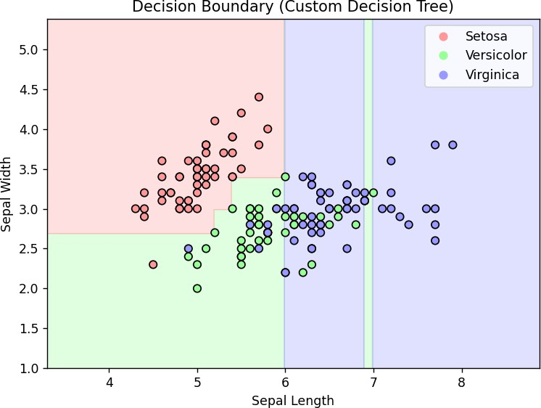

**LEARNING OUTCOME:**

# EXPERIMENT 10

**AIM:** Write a program for performing K-means clustering with and without using libraries.

**THEORY:**

## K-MEANS CLUSTERING (WITH LIBRARIES):

**CODE:**

import numpy as np

import matplotlib.pyplot as plt import pandas as pd

from sklearn.cluster import KMeans from sklearn import datasets

# Load Iris dataset

iris = datasets.load_iris()

X = iris.data[:, [2, 3]] # Using petal length and petal width for clustering

# Using the Elbow Method to find the optimal number of clusters wcss = []

for i in range(1, 11):

kmeans = KMeans(n_clusters=i, init='k-means++', n_init=10, random_state=42) kmeans.fit(X)

wcss.append(kmeans.inertia_)

# Plot the Elbow Method

plt.plot(range(1, 11), wcss, marker='o') plt.title('The Elbow Curve')

plt.xlabel('Number of clusters') plt.ylabel('WCSS')

plt.show()

# Applying K-Means with the chosen number of clusters (3 for Iris dataset)

kmeans = KMeans(n_clusters=4, init='k-means++', n_init=10, random_state=42) y_kmeans = kmeans.fit_predict(X)

# Visualizing the clusters colors = ['red', 'blue', 'green'] for i in range(3):

plt.scatter(X[y_kmeans == i, 0], X[y_kmeans == i, 1], s=11, c=colors[i], label=f'Cluster {i+1}')

# Plot centroids

plt.scatter(kmeans.cluster_centers_[:, 0], kmeans.cluster_centers_[:, 1], s=300, c='yellow', edgecolors='black', marker='X', label='Centroids')

plt.title('Clusters of Iris flowers') plt.xlabel('Petal Length (cm)')

plt.ylabel('Petal Width (cm)') plt.legend()

plt.show()

**CODE OUTPUT:**

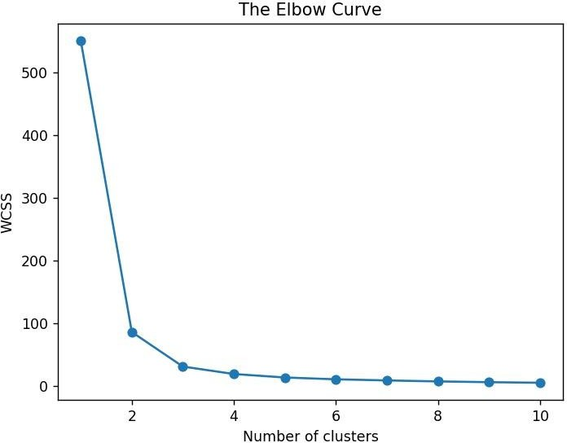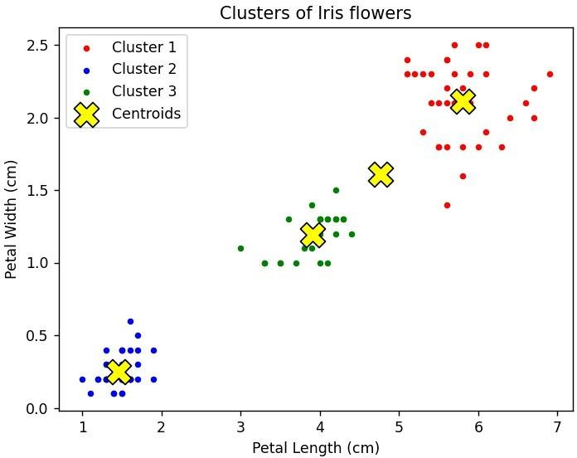

## K-MEANS CLUSTERING (WITHOUT LIBRARIES):

**CODE:**

import random

import matplotlib.pyplot as plt

# Load Iris dataset manually iris_data = [

[1.4, 0.2], [1.4, 0.2], [1.3, 0.2], [1.5, 0.2], [1.4, 0.2],

[4.7, 1.4], [4.5, 1.5], [4.9, 1.5], [4.0, 1.3], [4.6, 1.5],

[5.1, 1.9], [5.9, 2.1], [5.7, 2.3], [5.2, 2.0], [5.0, 1.9]

]

X = iris_data # Using petal length and petal width for clustering

# Euclidean distance function def euclidean_distance(p1, p2):

return sum((x - y) ** 2 for x, y in zip(p1, p2)) ** 0.5

# K-Means implementation without libraries def kmeans_manual(data, k, max_iters=100):

centroids = random.sample(data, k) for _ in range(max_iters):

clusters = [[] for _ in range(k)] for point in data:

distances = [euclidean_distance(point, centroid) for centroid in centroids] cluster_idx = distances.index(min(distances))

clusters[cluster_idx].append(point) new_centroids = []

for i, cluster in enumerate(clusters):

if cluster:

new_centroids.append([sum(dim) / len(cluster) for dim in zip(*cluster)]) else:

new_centroids.append(centroids[i]) # Retain previous centroid if cluster is empty if new_centroids == centroids:

break

centroids = new_centroids return clusters, centroids

# Running K-Means k = 3

clusters, centroids = kmeans_manual(X, k)

# Visualizing clusters

colors = ['red', 'blue', 'green']

for i, cluster in enumerate(clusters):

if cluster: # Ensure cluster is not empty x_vals, y_vals = zip(*cluster)

plt.scatter(x_vals, y_vals, s=100, c=colors[i], label=f'Cluster {i+1}')

# Plot centroids

x_centroids, y_centroids = zip(*centroids)

plt.scatter(x_centroids, y_centroids, s=300, c='yellow', edgecolors='black', marker='X', label='Centroids')

plt.title('Clusters of Iris flowers (Manual K-Means)') plt.xlabel('Petal Length (cm)')

plt.ylabel('Petal Width (cm)') plt.legend()

plt.show()

**CODE OUTPUT:**

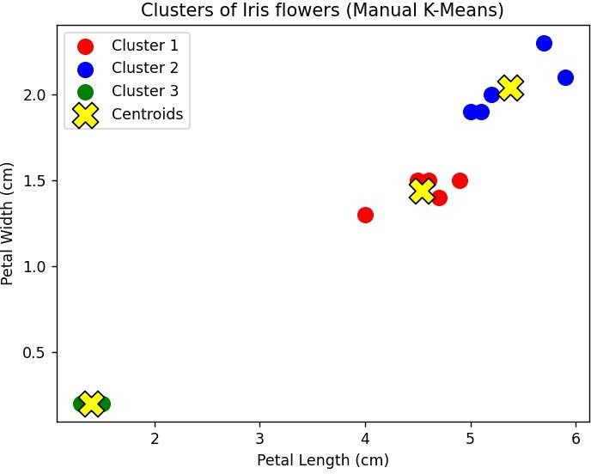

**LEARNING OUTCOME:**

# EXPERIMENT 11

**AIM:** Write a program for showing comparison of machine learning algorithms based on different-different parameters

**THEORY:**

## CODE:

import numpy as np import pandas as pd

from sklearn.model_selection import train_test_split

from sklearn.metrics import accuracy_score, precision_score, recall_score, f1_score from sklearn.ensemble import RandomForestClassifier

from sklearn.svm import SVC

from sklearn.linear_model import LogisticRegression from sklearn.datasets import load_iris

# Load dataset data = load_iris()

X = data.data y = data.target

# Split data

X_train, X_test, y_train, y_test = train_test_split(X, y, test_size=0.2, random_state=42)

# Define models models = {

"Random Forest": RandomForestClassifier(), "SVM": SVC(),

"Logistic Regression": LogisticRegression(max_iter=200)

}

# Evaluate models results = []

for name, model in models.items(): model.fit(X_train, y_train)

y_pred = model.predict(X_test)

accuracy = accuracy_score(y_test, y_pred)

precision = precision_score(y_test, y_pred, average='weighted') recall = recall_score(y_test, y_pred, average='weighted')

f1 = f1_score(y_test, y_pred, average='weighted')

results.append([name, accuracy, precision, recall, f1])

# Convert to DataFrame and display

results_df = pd.DataFrame(results, columns=["Model", "Accuracy", "Precision", "Recall", "F1-score"]) print(results_df)

**CODE OUTPUT:**

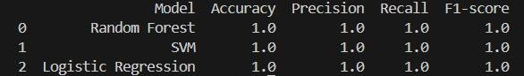

**LEARNING OUTCOME:**